

**Computer Vision Project Group - 7**

**Week-8: Progress Report**

**Project Title:**

**American Sign Language Alphabet Detection**

**Submitted to faculty: Prof. Mehul Raval**

**Group Members:**

| **JILL SHAH** | **AU2040234** |
| --- | --- |
| **KHUSHEE VAKIL** | **AU2040242** |
| **DHRUVI SHAH** | **AU2040263** |

**Work done:**

We have completed the project. But we have used simple Resnet instead of Resnet152 as it needed more computational resources and much more training time.

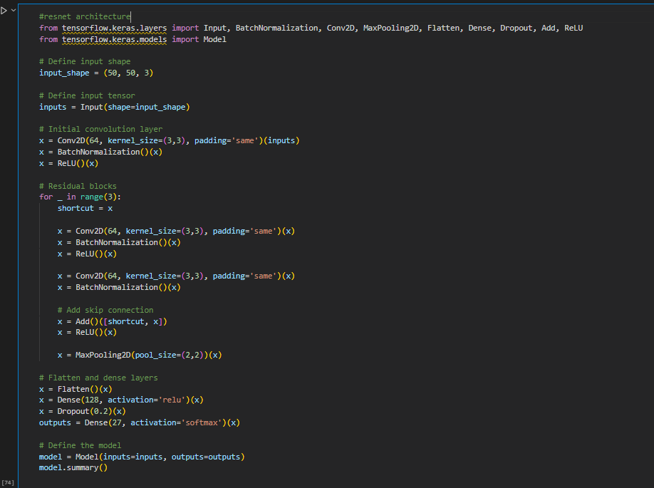

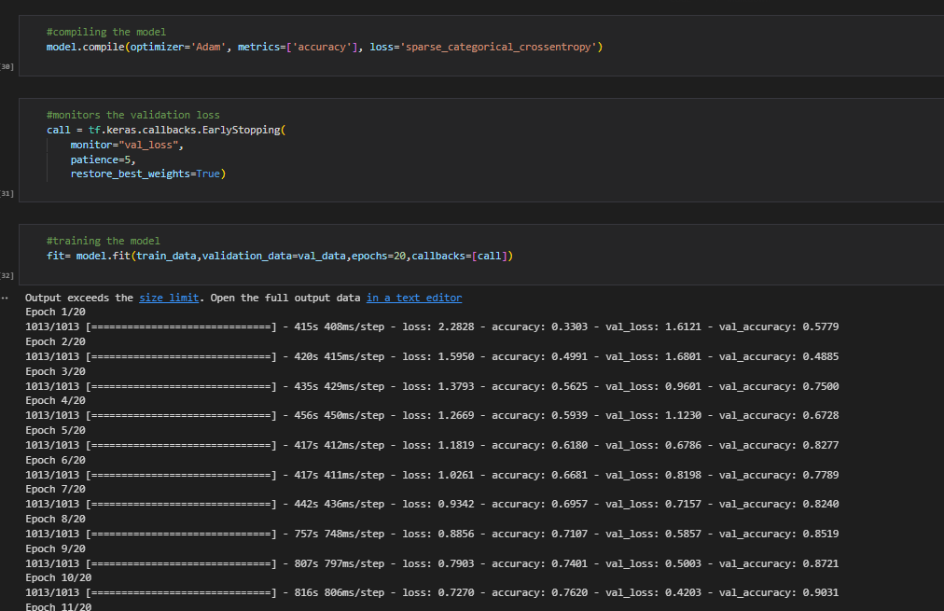

**We trained our model for 20 epochs and achieved 97.28%.**

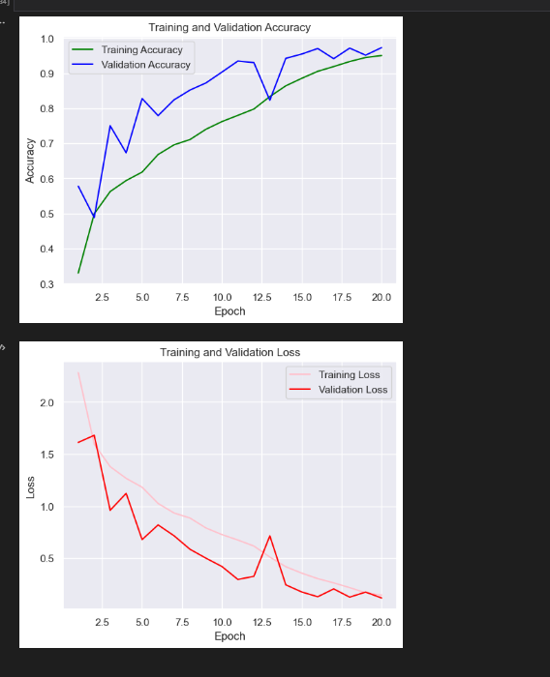

And we also faced some computational and system problems in real time detection. So we tried loading an image and predicted that particular class, which was successful.

**Our results:**

